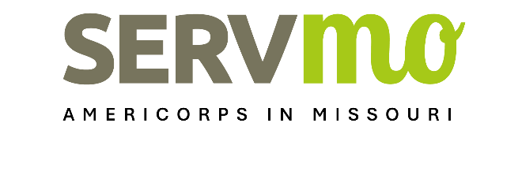
Performance Measures Template
AmeriCorps State and National

Instructions: Please use the AmeriCorps Performance Measures Instructions 2025 and the definitions provided to to guide you when completing the template on the following page. Applications must include at least one aligned performance measure (output paired with outcome) that corresponds to the proposed primary intervention. This may be a National Performance Measure or an applicant-determined measure depending on the program design.

Terminology | Definition
Activities | The primary service activities that AmeriCorps members will undertake to produce the specific outputs and achieve outcomes.
Inputs | The resources your program will use to produce outputs and achieve outcomes. Examples include staff, AmeriCorps members, volunteers, facilities, equipment, training curricula, and funding.
Intervention | The program model, including design and dosage, that addresses the community need.
Long-term Outcomes | The measurable impact on the stated community need as a result of the service activities that will occur beyond the three-year grant cycle.
Mid-term Outcomes | The measurable intermediate change that will occur as a result of the service activities, usually measurable over the course of the grant cycles (2-3 years).
Short-term Outcomes | The measurable intermediate change that will occur as a result of the service activities, measurable at the end of the program year.
Outputs | The measurable evidence of the services activities delivered by your program including projects completed by your AmeriCorps members.
Output/Outcome Instrument | The instruments that will be used to collect data for each output, intermediate outcome, and end outcome. For example: Twenty educational outreach sessions will be measured by training agendas, sign-in sheets, and pre- and post-tests.
Output/Outcome Target | The target number you expect to reach for each measure.
Problem Statement | A description of the specific unmet need, problem, or issue in the community that your AmeriCorps program will address (e.g. low literacy levels, lack of affordable housing, watershed pollution).

Problem Statement: Provide one to three sentences describing the community need.

Described Intervention: Provide a small paragraph describing type of intervention, design and dosage of intervention – intensity, frequency, duration.

OUTPUT
Title: Write the National Performance Number output number and title. If the applicant has determined to create a new measurement, create an appropriate title
Output Target: Enter a number of beneficiaries, individuals, or structures – do not use percentages
Output Unit of Measure: Describe what is measured (i.e. clients, children, miles, etc.)
Output Instrument: Describe the data collection tool and method. Include a definitition of the minimum dosage necessary to be counted as served, if applicable. Refer to the “How to Measure/Collect Data” information in the National Performance Measures Instructions.
OUTCOME
Title: Write the National Performance Number outcome aligned to the output entered above. If the applicant has determined to create a new measurement, create an appropriate title
Outcome Target: Enter a number of beneficiaries, individuals, or structures – do not use percentages
Outcome Unit of Measure: Identify what is measured (i.e. clients, children, miles, etc.)
Outcome Instrument: Describe the data collection tool and method to measure a change in knowledge, behavior, or condition. Include a definitition of success. Refer to the “How to Measure/Collect Data” information in the National Performance Measures Instructions.

In the rare circumstance that the applicant needs to submit more than one Performance Measure output/outcome pair, please submit a separate Template for each set of performance measures.

